**Project Design Phase-II**

**Technology Stack (Architecture & Stack)**

|  |  |
| --- | --- |
| Date | 19/05/2025 – 30/06/2025 |
| Team ID | LTVIP2025TMID31711 |
| Project Name | HealthAI: Intelligent Healthcare Assistant Using IBM Granite |
| Maximum Marks | 4 Marks |

**Technical Architecture:**

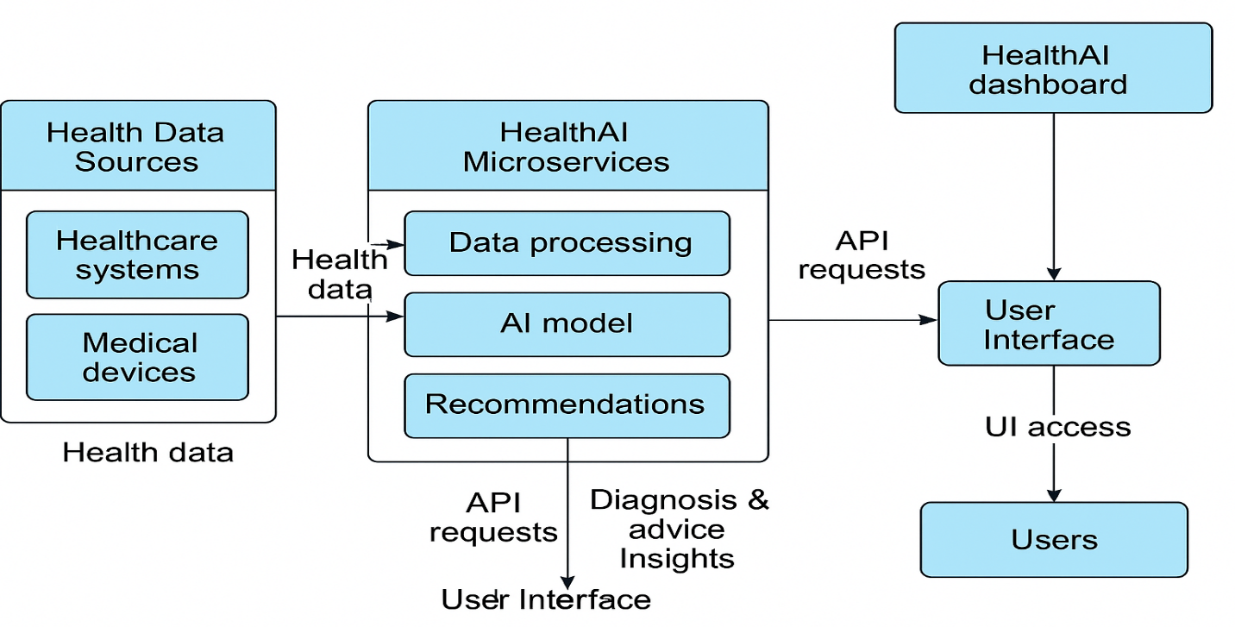

**1. Processes (Application Logic / Technology Blocks)**

|  |  |  |
| --- | --- | --- |
| **Component** | **Description** | **Technology Used** |
| **User Interface** | Frontend for user interaction (profile, symptoms, chatbot, reports) | Streamlit (Python), HTML |
| **Data Input & Validation** | Collects and validates user health data | Python |
| **Symptom Checker** | Extracts symptoms and triggers diagnosis logic | Python logic |
| **AI Diagnosis Model** | Predicts possible disease | IBM Granite AI via Hugging Face Inference API |
| **Treatment Planner** | Suggests remedies/treatment plans | IBM Granite model + rule-based logic |
| **Chronic Management Module** | Logs and visualizes glucose, heart rate, etc. | Python, Matplotlib, Pandas |
| **Analytics Dashboard** | Visualizes trends and statistics | Streamlit, Plotly, SQLite |
| **Email Notifier (Optional)** | Sends treatment advice or reports via email | Gmail SMTP API |

**2. Infrastructural Demarcation**

|  |  |  |
| --- | --- | --- |
| **Layer** | **Description** | **Deployment** |
| **Frontend/UI** | Streamlit app, hosted via cloud | Streamlit Cloud / IBM Cloud |
| **Application Logic Layer** | Python backend handling AI calls and processing | Cloud (IBM Cloud Functions or App Engine) |
| **Model Layer** | Remote inference of IBM Granite model | Hugging Face Inference API |
| **Database** | Stores user profile, logs, history | Local SQLite or IBM Cloudant |
| **File Storage** | Store user-generated reports (optional) | Streamlit cache / IBM Object Storage |

**3. External Interfaces / Third-Party APIs**

|  |  |
| --- | --- |
| **API Name** | **Purpose** |
| **Hugging Face Inference API** | To access IBM Granite AI model |
| **Gmail SMTP** | Sending email confirmations or reports |
| (Optional) IBM Watson STT / TTS | For voice input/output extension |
| (Optional) Aadhar/Health APIs | For user identity or health records |

**4. Data Storage Components**

|  |  |  |
| --- | --- | --- |
| **Storage** | **Usage** | **Technology** |
| **Local Database** | User profiles, symptoms, logs | SQLite |
| **Cloud Database (optional)** | Scalable storage for large health logs | IBM Cloudant |
| **Temporary Storage** | Cached outputs, user-generated reports | Streamlit Cache / Local filesystem |

**5. Machine Learning Interface**

|  |  |  |
| --- | --- | --- |
| **Model** | **Purpose** | **Access Method** |
| **IBM Granite (13B Instruct)** | To understand symptoms, generate diagnosis, recommend treatment | Accessed via Hugging Face API |
| **(Optional) Health-specific fine-tuned models** | Future extension for disease classification or prediction | Can be added via custom fine-tuning |

**Table-1: Components & Technologies**

|  |  |  |  |
| --- | --- | --- | --- |
| **S.No** | **Component** | **Description** | **Technology** |
| 1 | User Interface | Web app interface | Streamlit, HTML/CSS |
| 2 | Application Logic-1 | Profile setup, data validation | Python |
| 3 | Application Logic-2 | Symptom checker | IBM Granite model via Hugging Face API |
| 4 | Application Logic-3 | Health Assistant Chatbot | IBM Watsonx |
| 5 | Database | Temporary data storage | Local JSON/SQLite |
| 6 | Cloud Database | Optional for scalable version | IBM Cloudant (future use) |
| 7 | File Storage | Upload logs, if any | Local filesystem or IBM Object Storage |
| 8 | External API-1 | Geolocation or Email Service | IP-API, SMTP Gmail |
| 9 | Machine Learning | Disease prediction | IBM Granite-13b-instruct-v2 |
| 10 | Infrastructure | Deployment | Streamlit Community Cloud or IBM Cloud (optional upgrade) |

**Table-2: Application Characteristics**

|  |  |  |  |
| --- | --- | --- | --- |
| **S.No** | **Characteristics** | **Description** | **Technology Used** |
| 1 | Open-Source Frameworks | Streamlit, Hugging Face Transformers | Python, Streamlit |
| 2 | Security Implementations | Email login, encrypted storage, session timeout | SHA-256 (if storing credentials) |
| 3 | Scalable Architecture | Can migrate to 3-tier architecture or microservices if required | IBM Cloud Foundry or Kubernetes |
| 4 | Availability | Local version always on, cloud-ready | IBM Cloud Load Balancer (future use) |
| 5 | Performance | Lightweight app, fast response with IBM models | CDN (optional), minimal delay AI model |